4TH QUESTION IS REALIZED USING LTSPICE SIMULATION PROGRAM

First of all, let us draw the circuit in the ltspice given in the question.



Then, include the models by creating a 180nm.txt file in the same directory with the circuit.asc file. Copy the given model codes into this txt file and include these models by using the .inc 180nm.txt spice directive.

a-) To ensure that our circuit operates correctly, we perform an DC analysis by using .op command

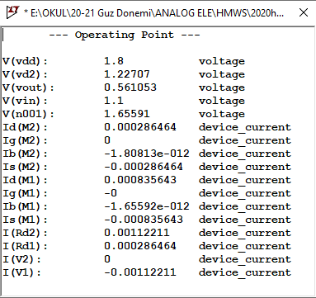

b-) Now, we are asked to find the closed loop gain, input and output impedances.

We add 1V AC to easily find the closed loop gain in the AC analysis.

By using the command .ac dec 100k 1k 100giga. We can see the gain over a range of frequencies

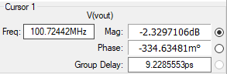

From this cursor, we can clearly see that our closed loop gain is

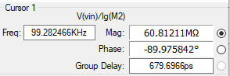To calculate closed loop input impedance, we take the ratio $\frac{Vin}{Ig(M2)}$

As it can be seen from the cursor, until high frequencies, input impedance is very high (in the order of megaohms) therefore it can be generally thought of infinity.

In order to calculate closed loop output impedance, we configure the circuit as follows (set the AC input voltage to zero, and tie a voltage source to the output).



After configuration of the circuit, we can calculate the closed loop output impedance by taking the ratio

${Rout}_{CL}= \frac{V_{x}}{I_{x}}$

And this ratio can be seen for a range of frequencies as follows



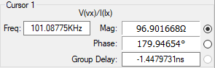

From the circuit it can be seen that, until high frequency dominates the closed loop output impedance is approximately ${Rout}_{CL}=100 Ω$